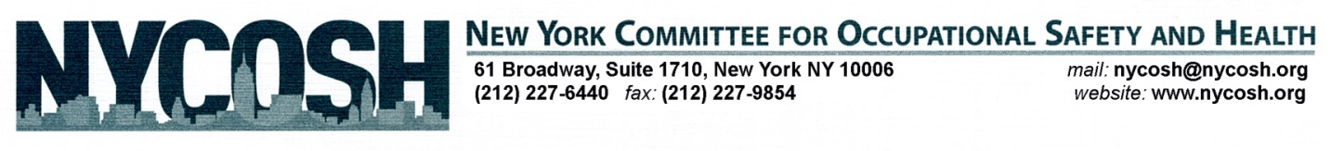
October 21, 2014

The Honorable Andrew M. Cuomo
Governor of New York State
New York State Capitol Building
Albany, NY 12224

CC: Mayor Bill de Blasio

Dear Governor Cuomo,

The New York Committee for Occupational Safety and Health (NYCOSH) would like to thank you for taking necessary steps to create an Ebola preparedness plan for New York State that includes worker education and training. While we believe that training at-risk workers is critical to ensuring the state’s preparedness for Ebola, the details of both the training curriculum and implementation remain unclear and will greatly impact the plan’s success and effectiveness.

NYCOSH is a non-profit membership organization of workers, unions, community–based organizations, and health and legal professionals that uses training and education to improve health and safety conditions in our workplaces and our communities. NYCOSH has been providing technical assistance and comprehensive training in environmental and occupational safety and health to over 10,000 workers annually for over 35 years. NYCOSH was at the forefront of disaster response and recovery efforts after the World Trade Center disaster, as well as after Sandy.

For workers with potential exposure to bloodborne pathogens (blood and other potentially infectious materials) and those with potential response duties should receive formal training that includes:

- Ebola awareness training
- Review of OSHA/PESH bloodborne pathogen standard and workplace instruction documents
- Safe work practices, including material, property, and personal decontamination.
- Personal protective equipment (PPE) selection, use, limitations, and donning and doffing.
- Safe work practice and PPE training that is “hands-on”, in addition to being “in-person”
This training should be standardized through the mandatory adoption and implementation of the Center for Disease Control’s most recent guidelines for frontline health care workers, which were created and utilized by the international aid group Doctors Without Borders and focus on three principles: that healthcare workers receive rigorous training and are competent with donning and doffing PPE, no skin is exposed, and all workers are supervised by a trained person who monitors the donning and doffing of PPE for every worker. To ensure that each hospital is able to effectively implement this program, the State should provide funding to train all Ebola on-site managers as well as all personnel who are responsible for training in the facilities. The New York State Department of Health should be responsible for the implementation of this program.

In addition to healthcare workers, all workers who are at risk of potential contact with infectious persons in the course of fulfilling their job duties—including air and mass transit workers, airport workers, educational staff, etc.—should receive basic Ebola information regarding the nature of the virus, modes of transmission, risk factors, symptoms, treatment, infection control and worker protection measures, and workplace policies. Information sharing can take the form of posters, handouts, and safety or paycheck informational meetings.

For an Ebola preparedness plan to be effective, it must include these critical components of worker education and hands-on training, create master trainers in New York State, and be properly funded to ensure the plan’s implementation.

Please reach out to us with any questions or concerns, and thank you again for your leadership on this important initiative.

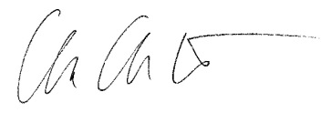
Sincerely,

Charlene Obernauer
Executive Director
New York Committee for Occupational Safety and Health

